Name : | Muhammad Taha
CMS ID : | 518133

Lesson Set 7 | For LOOP
Purpose | - Understand the purpose of for repetition structure.  - Understand the usage of for repetition structure.  - Understand the syntax and working of for looping statement.
Procedure | - Students should read the Pre-lab Reading Assignment before coming to lab.  - Students should complete the Pre-lab Writing Assignment before coming to lab.  - In the lab, students should complete Labs 7.1 through 7.4 in sequence.  - Your instructor will give further instructions as to grading and completion of the lab.  - Students should complete the set of lab tasks before the next lab and get them checked by their lab instructor.
 | Contents | Pre-requisites | Completion Time | Page Number
 | Pre-lab Reading Assignment | - | 20 min | 2
 | Lab 7
 | Lab 7.1  For Loop (Sum of numbers from 1 to n) | Basic understanding of looping | 30 min | 4
 | Lab 7.2  For Loop (Factorial) | Basic understanding of looping | 30 min | 4
 | Lab 7.3  For Loop (Squares of numbers) | Basic understanding of looping | 30 min | 5
 | Lab 7.4  Lab Tasks | Understanding of  While and do-while loop | 60 min | 6

PRE-LAB READING ASSIGNMENT
The For Loop | Often in programming one needs a statement or block of statements to repeat during execution. This can be accomplished using a loop. A loop is a control structure that causes repetition of code within a program. C++ has three types of loops. In the list of loops, the second one is the for loop. The syntax is the following:  for (initialization; condition; update)  {  statement_1;  statement_2;  :  :  statement_n;  }  Here initialization and update arguments are optional. If there is only one statement, then the curly braces can be omitted. When a for loop is encountered during execution, the expression is tested to see if it is true or false. The block of statements is repeated as long as the expression is true, & loop ends when the condition evaluates to false. Consider the following:  #include <iostream>  using namespace std;  int main()  {  int num = 2;  int Temp;  for(int i = 1; i<=10; i++)  {  Temp = num * I;  Cout<<num <<” x ”<< i << ” = ” << Temp <<endl;  }  system(”pause”);  return 0;  }  This program calculates and displays the table of number 2 from 1 to 10. Note how the while loop controls the execution. Here ‘i’ is initialized with a 1 and is changed by until it becomes 10 and the execution stops as soon as ‘i’ becomes 11. It calculates and prints the result of each calculation at each iteration. For loop is often used for applications that require a counter. For example, suppose we want to find the average (mean) of the first n positive integers. By definition, this means that we need to add 1 + 2 + 3 + . . . + n and then divide by n. Note this should just give us the value in the “middle” of the list 1, 2, ., n. Since we know exactly how many times we are performing a sum, the for loop is the natural choice.
Initialization | The initialization expression is typically used to initialize a counter that must have a starting value. This is the first action performed by the loop and is done only once.
Condition | The test expression, as with the while and do-while loops, is used to control the execution of the loop. As long as the test expression is true, the for loop's body repeats. The for loop is a pre-test loop which means that the test expression is evaluated before each iteration.
Update Expression | The update expression is executed at the end of each iteration. It typically increments or decrements the counter.

Lab 7
Lab 7.1 | - Once you have opened the visual studio code copy the following code in the code editor, try to run the code and observe the output. Write down the output that appears on the screen in the space given below  #include <iostream>  using namespace std;  int main()  {  int value;  int total = 0;  int number;  float mean;  cout << "Please enter a positive integer" << endl;  cin >> value;  if (value > 0)  {  for (number = 1; number <= value; number++)  {  total = total + number;  }  mean = static_cast<float>(total) / value;  cout << "The mean average of the first " << value  << " positive integers is " << mean << endl;  }  else  cout << "Invalid input " << endl;  return 0;  }  Please enter a positive integer  10  The mean average of the first 10 positive integers is 5.5
Lab 7.2 | - Create a new project with new file called lab7.2.cpp, copy the following  code it and try to fill the missing code of the program. Observe the output that appears and write it in the box given below  #include <iostream>  using namespace std;  int main()  {  long n, factorial = 1;  cout << "Enter a positive integer: ";  cin >> n;  for (int i = 1; i <= n; ++i) {  factorial = factorial * i;  }  cout<< "Factorial of "<<n<<" = "<<factorial;  return 0;  }  Enter a positive integer: 22  Factorial of 22 = -522715136  PS F:\Programming Fundamental\Labs\Lab 07> g++ test.cpp  PS F:\Programming Fundamental\Labs\Lab 07> .\a.exe  Enter a positive integer: 34  Factorial of 34 = 0  PS F:\Programming Fundamental\Labs\Lab 07> g++ test.cpp  PS F:\Programming Fundamental\Labs\Lab 07> .\a.exe  Enter a positive integer: 12  Factorial of 12 = 479001600  PS F:\Programming Fundamental\Labs\Lab 07>
Lab 7.3 | - Create a new project called 7.3.cpp, copy the following code it and try to run the program. Observe the output that appears and write it in the box given below  #include <iostream>  using namespace std;  int main ()  {  for(int i = 1; i<=50; i++)  {  cout<< “Square of Number ”<< i << “ is “<< i*i<<endl;  }  system(“pause”);  return 0;}  Square of Number 1 is 1  Square of Number 2 is 4  Square of Number 3 is 9  Square of Number 4 is 16  Square of Number 5 is 25  Square of Number 6 is 36  Square of Number 7 is 49  Square of Number 8 is 64  Square of Number 9 is 81  Square of Number 10 is 100  Square of Number 11 is 121  Square of Number 12 is 144  Square of Number 13 is 169  Square of Number 14 is 196  Square of Number 15 is 225  Square of Number 16 is 256  Square of Number 17 is 289  Square of Number 18 is 324  Square of Number 19 is 361  Square of Number 20 is 400  Square of Number 21 is 441  Square of Number 22 is 484  Square of Number 23 is 529  Square of Number 24 is 576  Square of Number 25 is 625  Square of Number 26 is 676  Square of Number 27 is 729  Square of Number 28 is 784  Square of Number 29 is 841  Square of Number 30 is 900  Square of Number 31 is 961  Square of Number 32 is 1024  Square of Number 33 is 1089  Square of Number 34 is 1156  Square of Number 35 is 1225  Square of Number 36 is 1296  Square of Number 37 is 1369  Square of Number 38 is 1444  Square of Number 39 is 1521  Square of Number 40 is 1600  Square of Number 41 is 1681  Square of Number 42 is 1764  Square of Number 43 is 1849  Square of Number 44 is 1936  Square of Number 45 is 2025  Square of Number 46 is 2116  Square of Number 47 is 2209  Square of Number 48 is 2304  Square of Number 49 is 2401  Square of Number 50 is 2500

Lab 7.4 | Lab Tasks

- Create a program that allows the user to enter the ages (in years) of five people. The program should display the average age. Use the for statement. Display the average age with one decimal place.
Name : | Muhammad Taha
CMS ID : | 518133
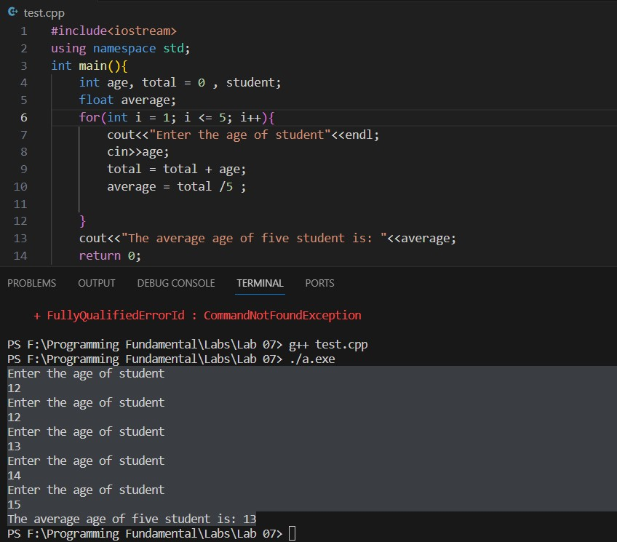

- Create a program that takes the ages of ten students as input and at the end it displays the minimum and the maximum ages entered.
Name : | Muhammad Taha
CMS ID : | 518133
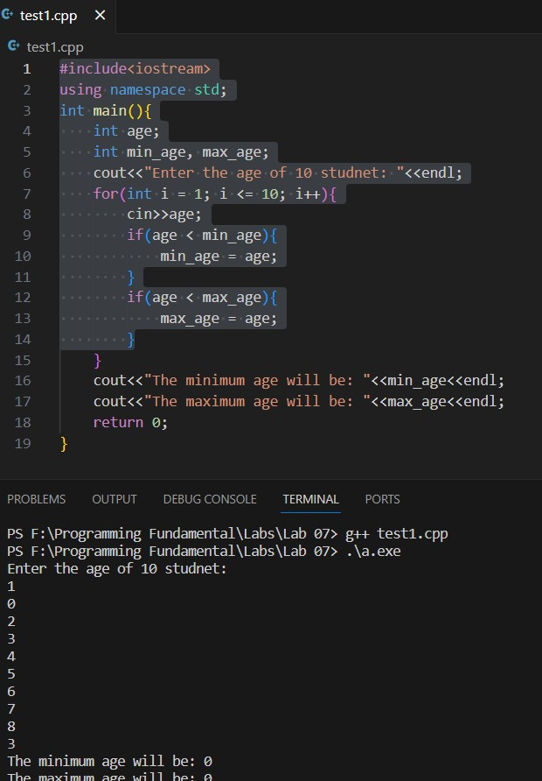

- Write a program that simulates the clocks, the clock should display seconds, minutes and hours. The minutes changes when a 60 second cycle is completed the clock, the hours changes at 60 minutes. The clock should stop after 2 hours. A sample display of the program as follows:
Name : | Muhammad Taha
CMS ID : | 518133
